Slide 1:
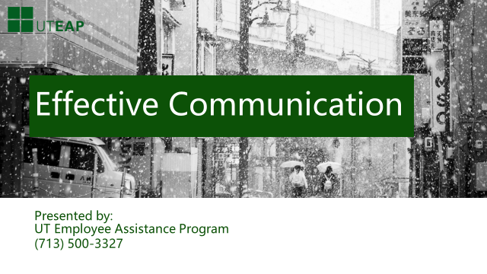
Communication. We all communicate constantly even when we don’t realize that is what we are doing. Rolling your eyes when your husband tells you he forgot to take out the garbage. Explaining your position regarding the new project your team has been assigned. Listening to a co-worker’s presentation. These are all ways we communicate. Whether we are sending the message or receiving it, communication is a process with which we are continuously involved. How then do we sometimes miss meanings, misunderstand messages, or mismanage responses? If we communicate so often, how do we so often get it wrong?
We will talk today about effective communication.
Slide 2:
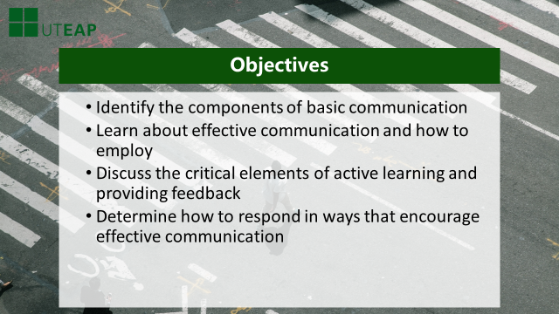
Our objectives for our time together today are:
- Identify the components of basic communication
- Learn about effective communication and how to employ
- Discuss the critical elements of active learning and providing feedback
- Determine how to respond in ways that encourage effective communication

Slide 3:
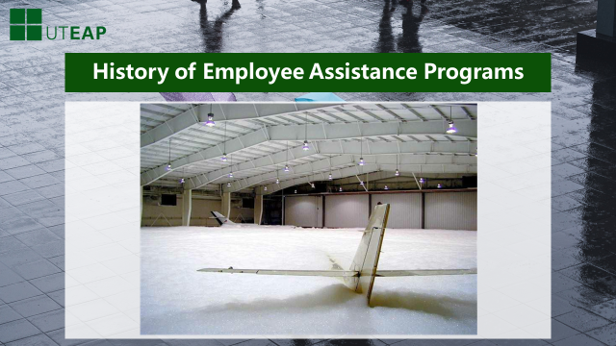
Imagine that you are the chief airplane washer at the company hangar and you:
- Hook a high pressure hose up to the soap suds machine.
- Turn the machine “on”.
- Receive an important call and have to leave work to go home.
- As you depart for home, you yell to Don, your assistant, “Don, turn it off.”
- Assistant Don thinks he hears, “Don’t turn it off.” He shrugs, and leaves the area right after you.
- Look at the picture above for the results!
**As with every conversation, make sure the other person has a clear understanding of what you are communicating.
Slide 4:
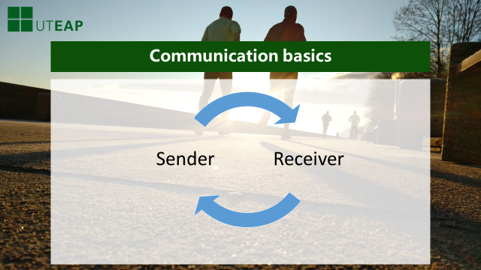
Communication is a system for transmitting AND exchanging information. As we see from the previous story, communication is about how we send and receive messages. Let’s take a look at how we do both….

Slide 5:
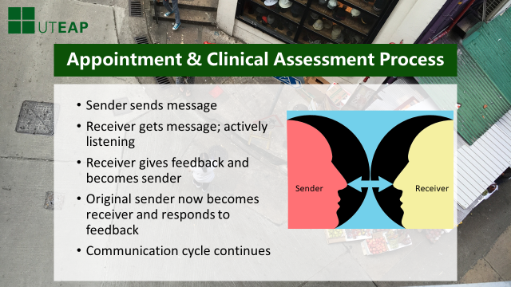
At it’s core, communication is a two-way process which involves a sender of the message and a receiver of that message. For effective communication to occur, the following happens:
- Sender sends message
- The receiver actively listens in order to get the message.
- The receiver, in turn, gives feedback and becomes the sender
- The original sender now becomes the receiver and responds to the feedback
- The communication cycle continues
For example, Cindy and Jim are communicating:
- Cindy tells Jim that she had a nice weekend
- Jim gets the message that Cindy had a good weekend.
- Jim gives her feedback by telling her that is nice and inquires about what she did over the weekend.
- Cindy, the original sender, now becomes the receiver and tells Jim that she went fishing with some friends.
- The cycle continues

Slide 6:
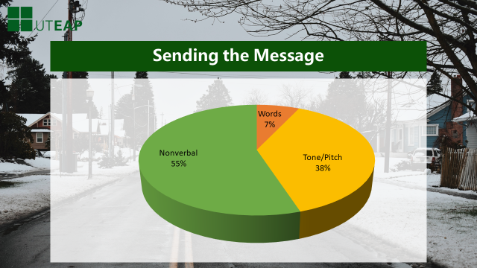
Effective communication is about sending clear concise message AND receiving and correctly understanding messages sent to us.
Let’s look at how we send messages.
Communication involves three components:
- Words – the words we use; the verbal component of the message. Research tells us that words account for only about 7% of what is perceived and understood by others.
- Tone/Pitch – how we say the words. This accounts for about 38% of what is understood by a listener.
- Nonverbal – our body language. Our posture, gestures, expressions account for 55%! What we don’t say with words is clearly a big factor in how we communication with others!

Slide 7:
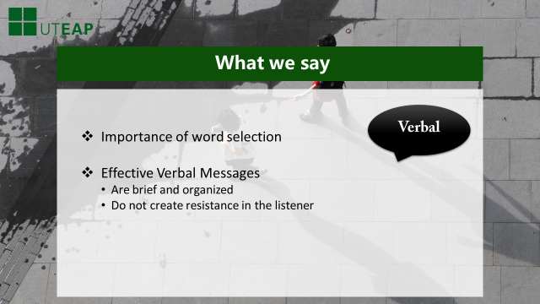
The words we use has great power in communication. We can choose words that are blaming, critical or those that are open, supportive. A statement such as:
“How could you make a stupid decision like that?” sends an entirely different message than “Help me to understand why you made that decision.” It is important to select words that are brief, organized and encourage the listener to participate in the conversation.
Slide 8:
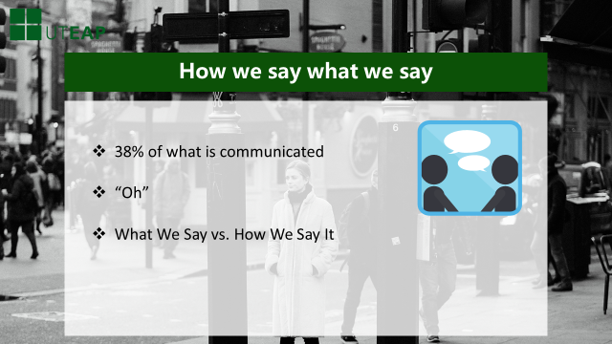
The way in which we say the words we choose is another important component in how we send messages. This type of communication includes messages we send through tone, pitch, volume, speed of speech. It accounts for 38% of what is communicated to others. A statement can express entirely different meanings based on emphasis placed on words. Take for example the word, “Oh.”
- Oh! - (here used as an exclamation) – “Oh! Jerry has been promoted to Team Lead!”
- Oh? – (questioning) – “Oh? Jerry has been promoted to Team Lead?”
- Oh – (disgust) – “Oh. Jerry has been promoted to Team Lead.”
- Oh – (disbelief) – “Oh. Jerry has been promoted to Team Lead.”
- Oh – (boredom) – “Oh. Jerry has been promoted to Team Lead.”
We see that switching tone, inflection or emphasis, the meaning of the same words can be drastically changed. It becomes obvious that what[emphasis] we say isn't nearly as important as how[emphasis] we say it.

Slide 9:
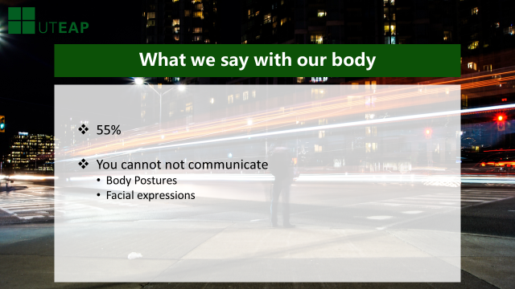
The final way in which we send messages is through what we say with our body = the nonverbal. Facial expressions, gestures are just some ways we communicate. Nonverbal messages are being received – nonverbal messages account for 55% of what is perceived and understood by others.
Body postures can suggest openness or disagreement. For example, crossed arms can communicate inflexibility. Facial expressions can portray confusion, frustration, disappointment, approval. Being aware of how nonverbal behavior can impact your message is essential in ensuring that the appropriate message is indeed received.
It is extremely important to send messages that are consistent in body language, words and tone.
Let’s take a look at the other part of effective communication: Listening.
Slide 10:
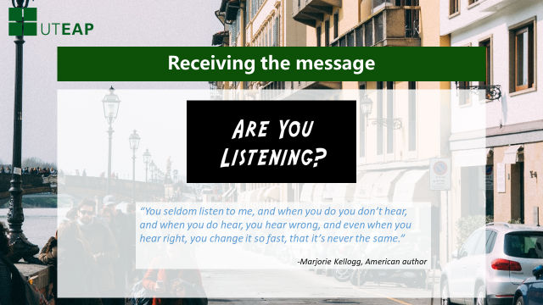
Consider the following quote:
“You seldom listen to me, and when you do you don't hear, and when you do hear you hear wrong, and even when you hear right you change it so fast that it's never the same.”
As the quote above implies, listening is not always as easy as it may appear. However, the key to receiving accurate messages is listening.

Slide 11:
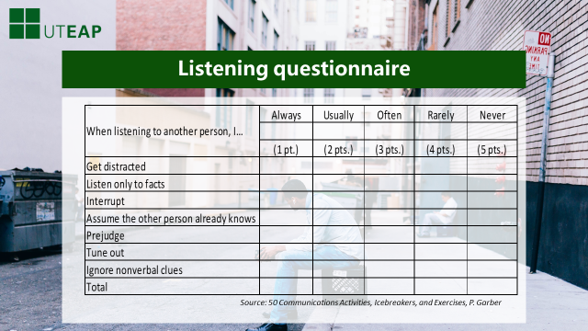
How well do YOU listen? Take a moment to complete the questionnaire above. For this self-assessment tool, your answers should honestly reflect how you listen to your co-workers and supervisors.
Once you have tallied your scores, please proceed to the next page.
Slide 12:
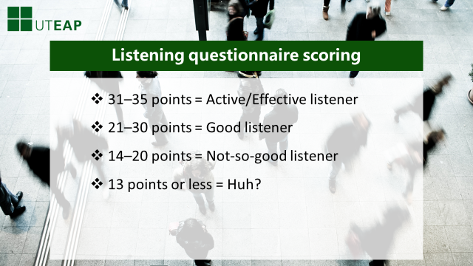
Here is the Scoring Guide. Take a few moments to identify your results. [3 second pause]
Were you surprised by the results?
Active, effective listening is more than simply hearing what the speaker is saying. Active listening is the most demanding level of listening because it requires concentration and energy. You listen in a way that includes not only the person’s words, but their thoughts and feelings. In order to accomplish this, you set aside your judgments and give complete attention to the message and intent of the speaker. You are, in a sense, “putting yourself into someone else’s shoes.” In turn, the listener sends feedback to the speaker to show that what is being said is really being understood.
Next we will look at a model that is useful in increasing your active listening skills.

Slide 13:
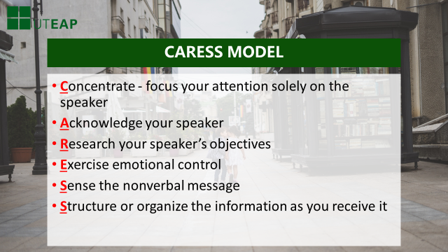
There are specific skills you can utilize that will assist you in becoming an active, effective listener.
Remember CARESS
- Concentrate and focus your attention solely on the speaker
- Acknowledge your speaker
- Research your speaker’s objectives
- Exercise emotional control
- Sense the nonverbal message
- Structure or organize the information as you receive it
*Let’s take a closer look at each one of these skills

Slide 14:
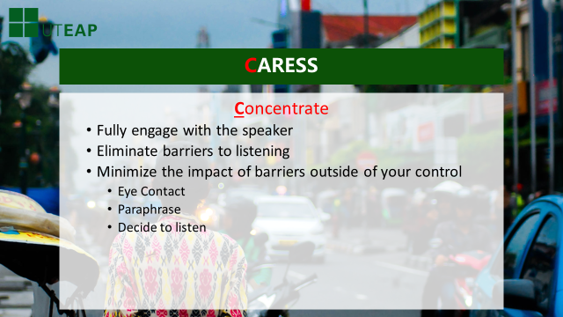
Concentrate
The first step in active listening is to CONCENTRATE or engage completely with the speaker. In order to accomplish this, the listener must eliminate “noise” and distractions. Examples of these barriers include:
- Arms crossed – This may be a signal to your speaker that you are not open or that you are not in agreement with what he/she is saying. Remember that nonverbal messages account for 55% of what is perceived by others.
- Physical proximity to speaker - If someone is too close or too far away from you, it may make you feel uncomfortable and block your ability to concentrate
- Shouting – as the listener, you may find this intimidating and difficult to effectively receive the message
- Noise in the room – you may have a difficult time receiving the message if there is a radio on, if there are constant visitors or phone calls interrupting the conversation
There may be circumstances when you will not be able to completely eliminate barriers from your work environment. There are ways that you can minimize their impact. Maintaining eye contact will help you to focus on the conversation. Paraphrase the main points of what the speaker has shared with you and mentally make the decision to listen.

Slide 15:
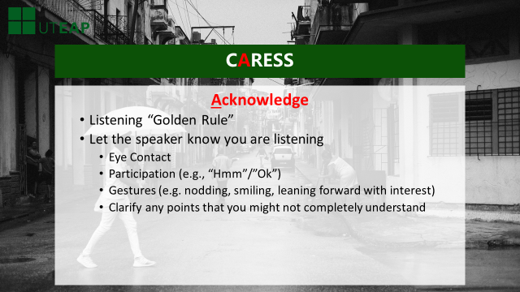
Acknowledging your speaker is the second step in helping you become an active listener.
- The Golden Rule tells us to treat others as we would like to be treated. The same holds true for with listening. Listen to the speaker in the same way you would like to be heard. This includes:
  - Maintaining Eye Contact
  - Participation/Gestures – be an active partner in the conversation by giving short responses such as “OK” or “I see.” Also gestures like nodding, smiling or leaning forward allows the speaker to feel like she/he is being heard
  - Clarifying any points you might not completely understand. Feedback in any conversation is important. Ask and probe for facts or information you may have missed.
Acknowledgement is a way to let the speaker know that you are engaged in the conversation and have received his/her message.

Slide 16:
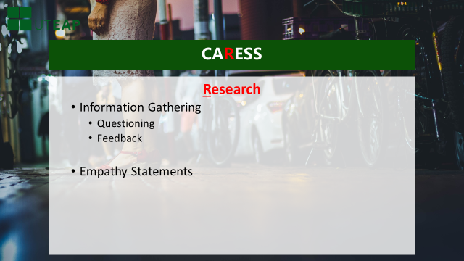
Research is the next step toward effective listening. It is imperative to gather information in order to receive accurate message.
When one person does all the talking while the other person simply listens and takes it all in, this could make the speaker uncomfortable as he/she is doing all the disclosing and the listener isn’t.
Asking the right questions at the appropriate time allows speaker to feel comfortable to share and continue communication.
- Empathy is a part of listening. Affirming the speaker’s feelings helps to build a bond between the speaker and listener. For example, “I am sensing that you are worried about the success of the project because of missed deadlines.” This gives you-the listener- another opportunity to acknowledge the speaker and let him/her know that you are actively listening.

Slide 17:
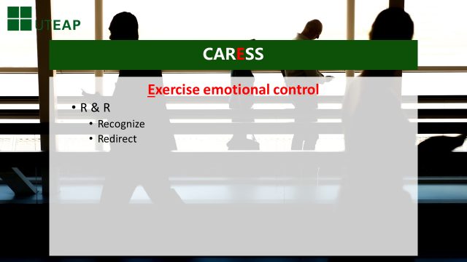
The next step in effective listening is to exercise emotional control.
There may be occasions during a conversation when you may hear a statement that causes a strong reaction. For example, if a speaker uses ethnic or political words, you may be offended. If you focus on this, you miss the substance of message.
Another occasion to be aware of is the role one’s own opinions and perceptions play in communication. Perceptions and opinions, while valid to the listener, can make communication difficult because the listener filters the speaker’s message through their perceptions/opinions. Perceptions that the speaker may have an ulterior motive or an opinion that the speaker does not like them are but a few examples of how the listener’s personal biases impede effective communication. The same holds true when the speaker filter’s the message content through their own perceptions and/or opinions. Recognizing and redirecting your own perceptions/opinions encourages open and effective communication. Exercise emotional control and you can avoid blocking meaning of the speaker’s message. Exercise emotional control and you can avoid blocking meaning of speaker’s messages.
- Recognize and Redirect your negative emotional reaction
Recognize – Pay attention to your physical responses. Is your heart beating faster? Can you feel your face flush? When this begins, there is a tendency to want to interrupt or argue with the speaker.
Redirect – Control the initial impulse and continue to listen for additional information. Look for common ground – What do you and the speaker have in common?
Once you have refocused the negative reaction, you will then be able to calmly ask clarifying questions to be able to better understand the speaker’s message.

Slide 18:
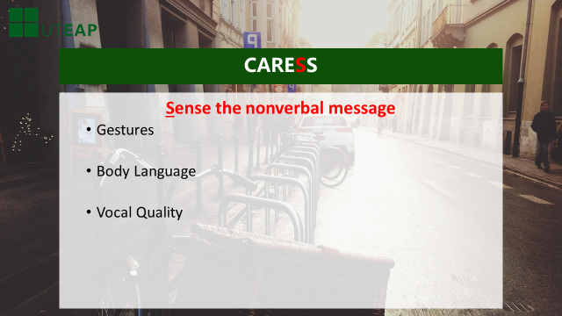
The next step is sensing the nonverbal cues the speaker is sending you.
We talked earlier about how nonverbal messages are a critical part of the speaker’s message. Be mindful of these messages sent via:
- Gestures
- Body language
- Vocal Qualities – this includes things such as volume, inflection, speed. A speaker talking very loudly may signal that he or she is upset or passionate about an issue. Recall our earlier example about how the emphasis placed on certain words can change the meaning of a message.
Pay attention to these nonverbal signals as you seek to receive an accurate message.

Slide 19:
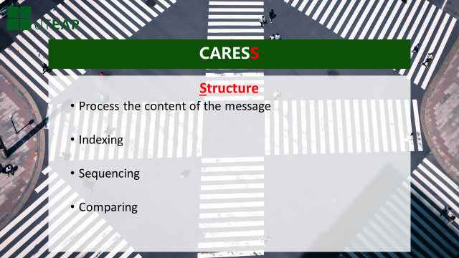
The final step in developing effective listening skills involves looking for structure or processing the actual content of the message.
This is where you listen to the actual words spoken.
What is the purpose of the meeting? The speaker may use wording such as “I wanted to meet with you today to discuss….” (what follows is probably the main idea, subject or the topic).
Listen to the speaker’s current message to see if it is consistent with prior messages he or she has sent.
As you are listening, if you’re unclear, seek clarity through feedback, researching and asking questions. For example “I want to ensure what the priorities are.”

Slide 20:
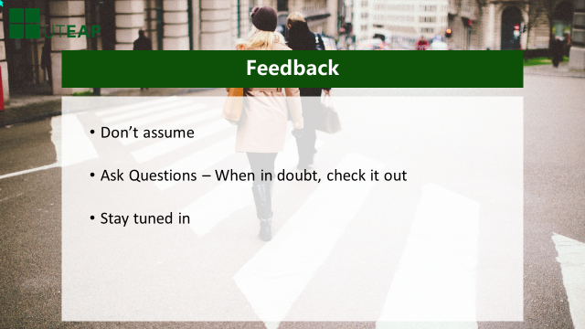
We have mentioned many times throughout the presentation, the importance of seeking and/or giving feedback. We seek feedback in order to ensure clarity and receive additional or missing information. We give feedback as a way to let the speaker know that we are actively involved in the conversation.
Feedback means…
- Not making assumptions about a speaker’s intention.
- Asking questions will alleviate any doubts you may have about the message being conveyed.
- Staying tuned in and engaged

Slide 21:
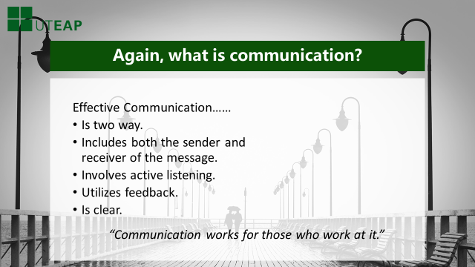
As we have learned today, communication involves how we send messages and how accurately we receive them.
Effective Communication……
Is two way.
Includes both the sender and receiver of the message.
Involves active listening.
Utilizes feedback.
Is clear.
“Communication works for those who work at it.” - John Powell
Slide 22
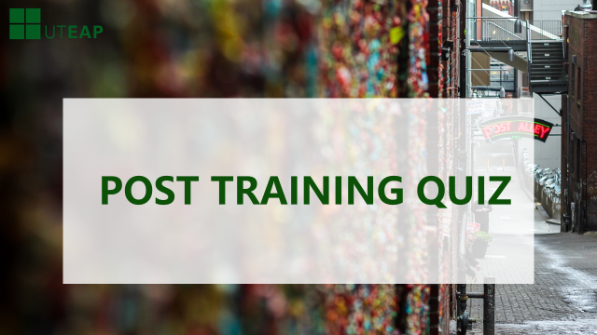
On behalf of the UT employee assistance program. I want to thank you for joining us in this training today. We hope you found it informative and interesting. It is now time to apply what you have learned by taking a short post-training quiz. You will need to pass this test in order to receive your certificate of completion. We are confident you will pass and if needed, you may print out the certificate at the end of the training to provide your HR representative as documentation of taking the class.
Thank you.

